COURSE CODE & NAME: ECE1408- EMEBEDDED SYSTEM
NAME: AADARSHIKA K
ROLL NO: 192565081

EX NO: 6
INDUSTRIAL HVAC CONTROL USING ADC AND TIMER-INTERRUPT PWM FAN CONTROL
1. Aim
To design and simulate an industrial HVAC control system using Arduino UNO for temperature acquisition through an LM35 sensor and fan speed control using Pulse Width Modulation (PWM).
2. Software and Hardware Requirements
Software:
- Arduino IDE
- Proteus Design Suite
Hardware / Simulation Components:
- Arduino UNO
- LM35 temperature sensor
- DC motor (representing the cooling fan)
- Motor driver (if required by the circuit)
- Resistors
- Virtual Terminal
- Connecting wires
3. Program code:
#define TEMP A0
#define FAN 8
volatile byte pwm = 0;
volatile byte count = 0;
ISR(TIMER1_COMPA_vect)
{
count++;
if (count >= 100)
count = 0;
digitalWrite(FAN, count < pwm);
}
void setup()
{
Serial.begin(9600);
pinMode(FAN, OUTPUT);
TCCR1A = 0;
TCCR1B = (1 << WGM12) | (1 << CS11);
OCR1A = 199;
TIMSK1 = (1 << OCIE1A);
sei();
}
void loop()
{
int adc = analogRead(TEMP);
float temp = adc * 500.0 / 1023.0;
if (temp < 25)
pwm = 0;
else if (temp < 30)
pwm = 30;
else if (temp < 35)
pwm = 60;
else
pwm = 90;
Serial.print("Temperature: ");
Serial.print(temp, 1);
Serial.print(" C PWM: ");
Serial.print(pwm);
Serial.println("%");
delay(1000);
}
4. OUTPUT:
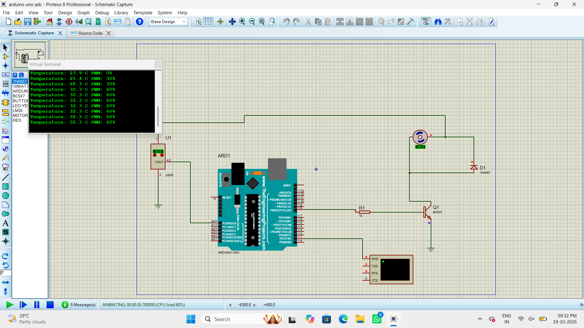
5. Result
Thus, the industrial HVAC control system was designed and simulated using Arduino UNO. The system acquires temperature readings from the LM35 sensor using ADC and controls the fan speed through PWM according to the programmed conditions.

